Team Members:

Daniel Rozhanskiy

Blessing Ademola

Color Balance and Fusion for Underwater Image Enhancement

Topic of Interest: Edge Detection

Problem Being Solved
Underwater images can make object detection difficult, especially at deeper depths of water due to light degradation. We will take a curated approach to this problem, by taking into account the fact the shorter wavelengths on the color spectrum (i.e. red) degrade first, followed by orange, yellow, etc.

Previous Work we’ve found
Link to paper: https://ieeexplore.ieee.org/document/8058463. The paper was published to IEEE in 2018 by Codruta O. Ancuti , Cosmin Ancuti, Christophe De Vleeschouwer , and Philippe Bekaert. The paper has 731 citations, especially by people using this as a preprocessing technique for Convolutional Neural Network training.

Algorithms/Methods we’ll be using
Their work basically applies white balancing Gray World color balancing with a few assumptions added on specific to the underwater medium. This helps us recover color information from hazy images. This is followed by deriving a gamma correction version and sharpened version of the white balanced image, then applying multiscale fusion to get the final result.

The multi scale fusion process will involve generating 3 weight maps: a laplacian contrast weight map, a saliency weight map, and a saturation weight map. But instead of fusing the 3 weight maps via a naive weighted summation, we will construct a Laplacian pyramid, and fuse via summation of the Laplacian pyramid levels to avoid undesirable halos in the processed image.

We will then apply the Laplacian of Gaussian (LoG) algorithm for edge detection and compare the accuracy between the original image and the final color balanced image.

Data
Inputs will be sample images from the paper

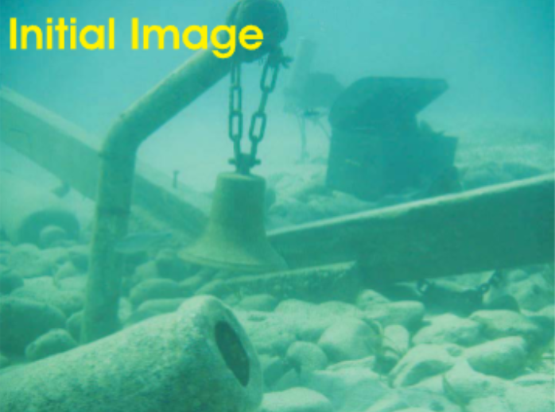
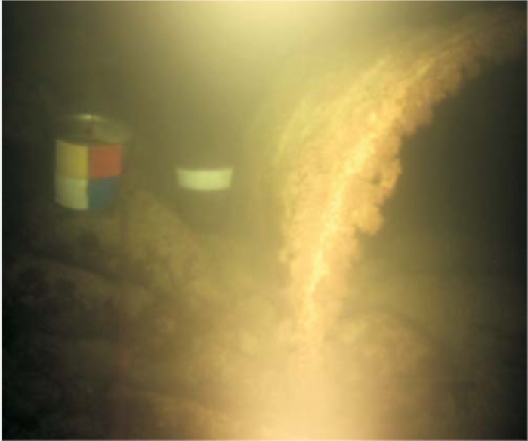

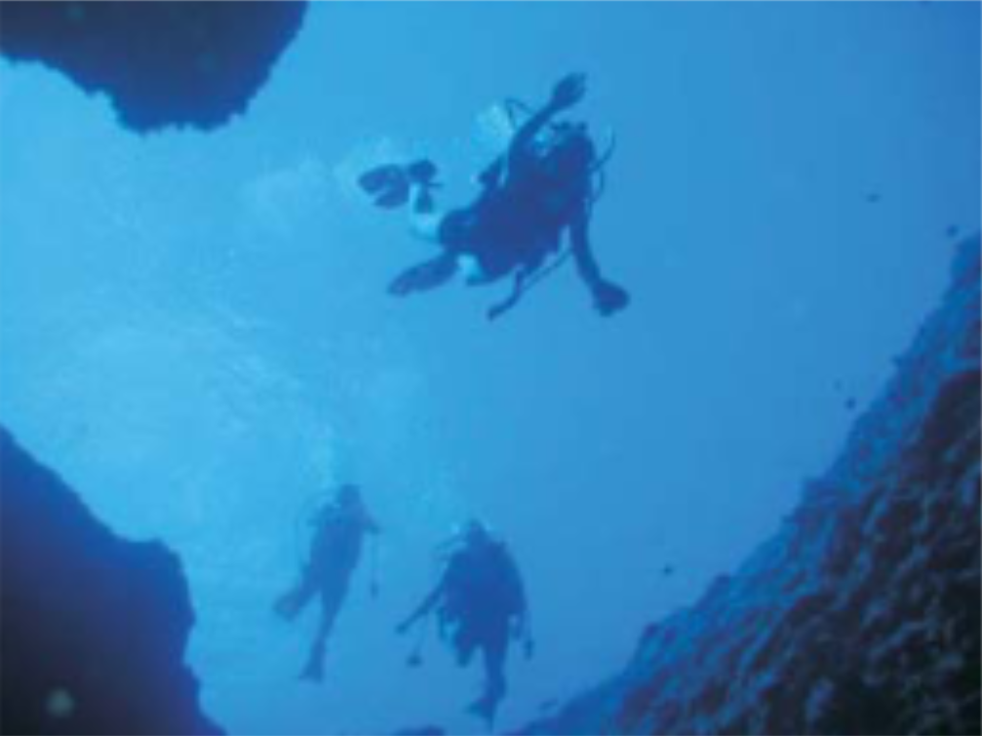
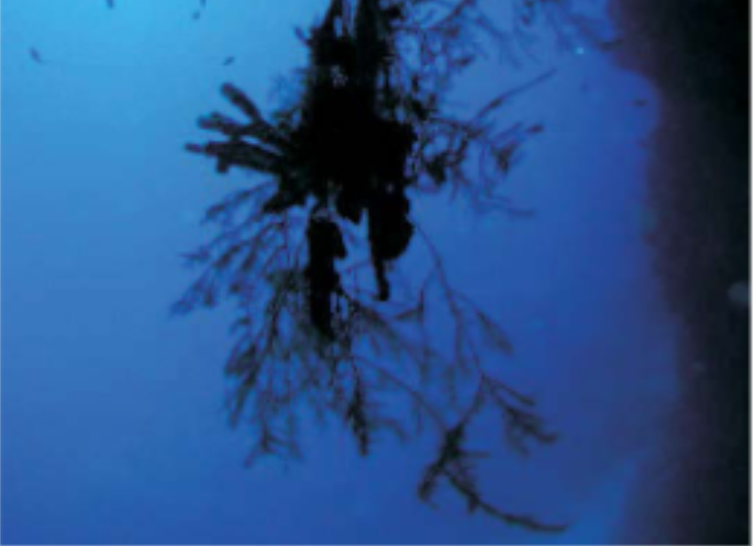

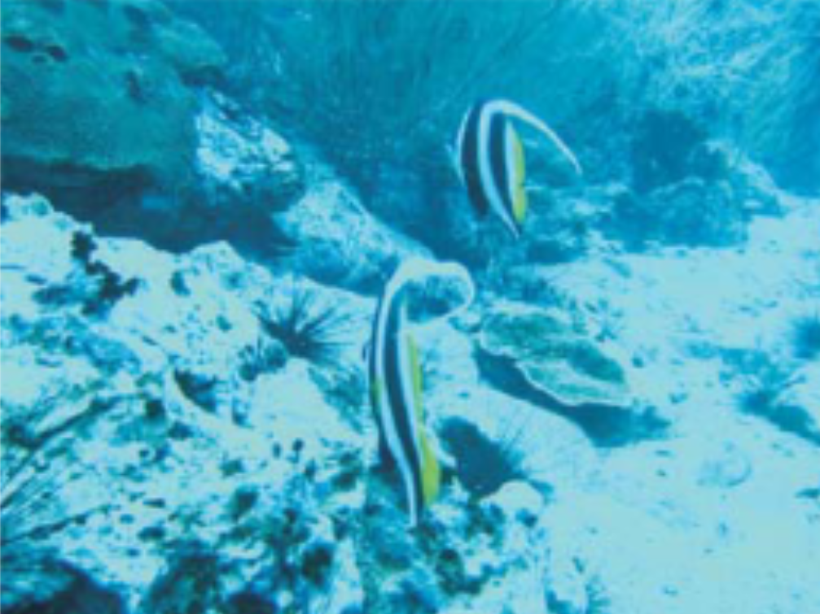
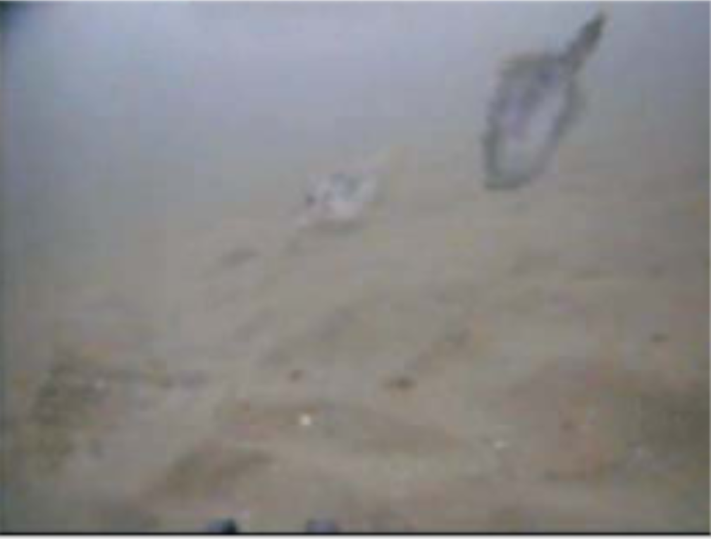

The output images will be the color corrected images, as well as a binary mask which represents the output of the object detection algorithm applied to the color corrected image.

Example output images so far

White balanced with alpha = 2.3 (higher than the alpha = 1 recommended by the paper, was too reddish for this image

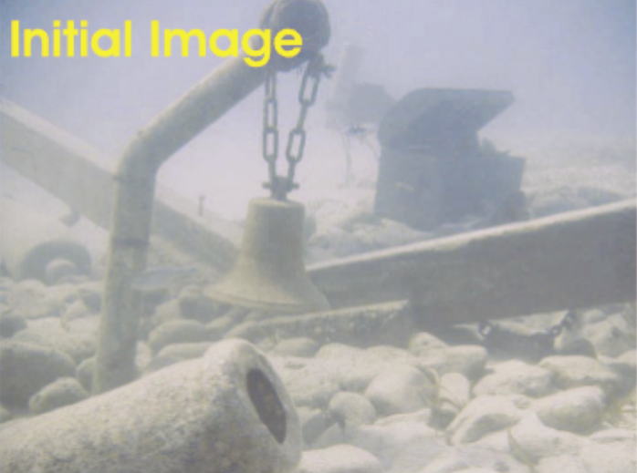

Sharpened image (created from white balanced image above)
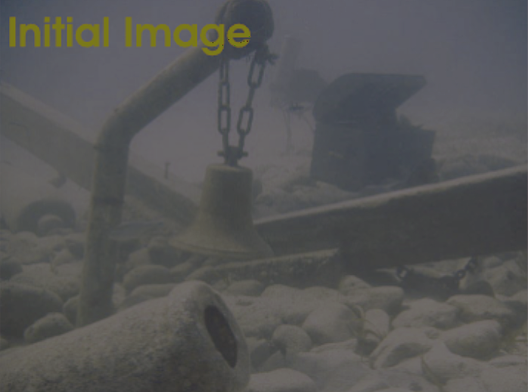

Gamma corrected image (gamma factor = 1.5, no gamma factor recommendations in the paper) (created from white balanced image above)

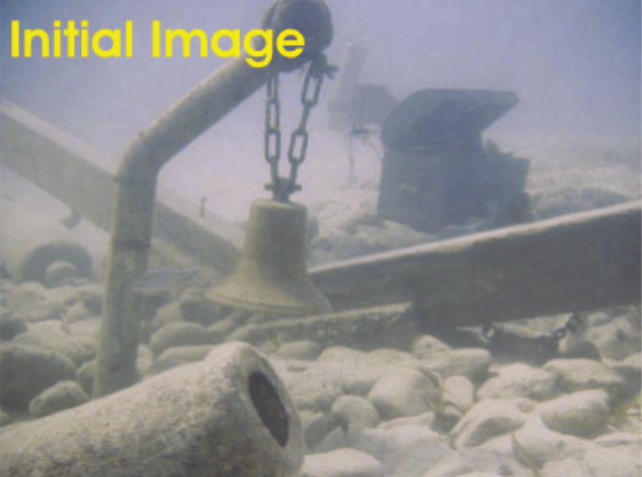

Both the Sharpened and Gamma corrected images will be inputs to the multi scale fusion process.

How we plan to test our methods
We will test our methods by applying the laplacian of gaussian edge detection algorithm to each of the input methods without the color correction, and after color correction, and comparing accuracy of both cases.

